**Python exception handling**

Error in Python can be of two types i.e. [Syntax errors and Exceptions](https://www.geeksforgeeks.org/errors-and-exceptions-in-python/).

* Errors are the problems in a program due to which the program will stop the execution.
* Exceptions are raised when some internal events occur which changes the normal flow of the program.

**Syntax Error:** As the name suggests this error is caused by the wrong syntax in the code.

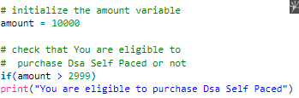

**Above is an example of Indentation errors……**

**Exceptions:** Exceptions are raised when the program is syntactically correct, but the code resulted in an error. This error does not stop the execution of the program, however, it changes the normal flow of the program.

How try -except works??

* If any exception occurs, the **try** clause will be skipped and **except** clause will run.
* If any exception occurs, but the **except** clause within the code doesn’t handle it, it is passed on to the outer **try** statements. If the exception is left unhandled, then the execution stops.

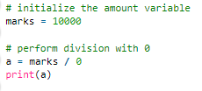

Exception is the base class for all the exceptions in Python. You can check the exception hierarchy

( <https://docs.python.org/2/library/exceptions.html#exception-hierarchy> )

**Some of the common Exception Errors are :**

* **IOError:**if the file can’t be opened
* **KeyboardInterrupt:**when an unrequired key is pressed by the user
* **ValueError:**when built-in function receives a wrong argument
* **EOFError:**if End-Of-File is hit without reading any data
* **ImportError:**if it is unable to find the module

Try and except statements are used to catch and handle exceptions in Python.

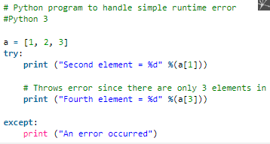

A try statement can have more than one except clause, to specify handlers for different exceptions. Please note that at most one handler will be executed.

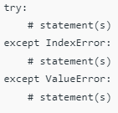

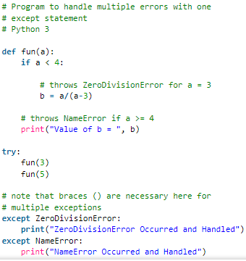

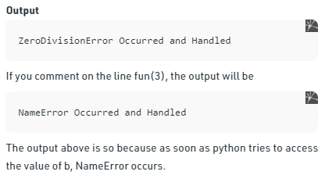

**Try with Else Clause**

In python, you can also use the else clause on the try-except block which must be present after all the except clauses. The code enters the else block only if the try clause does not raise an exception.

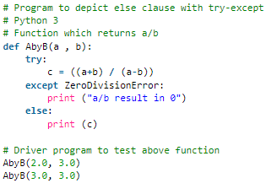

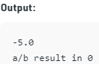

## Finally Keyword in Python

The final block always executes after normal termination of try block or after try block terminates due to some exception.

## 

## Raising Exception

The [raise statement](https://www.geeksforgeeks.org/python-raising-an-exception-to-another-exception/) allows the programmer to force a specific exception to occur.

The sole argument in raise indicates the exception to be raised which could be either an exception instance or an exception class (a class that derives from Exception).

